Analysis of Chemical Components in Cosmetic Products Using Data Science

1. Introduction
In recent years, the cosmetic industry has experienced rapid growth, with thousands of products available for consumers. While variety provides choice, it also creates confusion—especially for individuals with sensitive or dry skin. Cosmetic product labels list ingredients, but interpreting these chemical components requires specialized technical knowledge that most consumers lack. As a result, purchasing cosmetic products often involves trial and error, which can lead to skin irritation or allergic reactions.
This project addresses this challenge by applying data science and machine learning techniques to analyze cosmetic product ingredients and identify similarities between products. By building a content-based recommendation system, the project helps users understand which cosmetic products are chemically similar and therefore potentially suitable alternatives.
The core idea of the project is to treat cosmetic ingredients as textual data, convert them into numerical representations, and apply dimensionality reduction techniques to visualize similarities among products.
__________________________________________________________________________________
2. Objectives of the Project
The main objectives of this project are:
- To analyze cosmetic product ingredient compositions using data science techniques.
- To build a content-based recommendation system based on chemical ingredients.
- To focus on a specific product category (moisturizers) and skin type (dry skin).
- To convert ingredient lists into machine-readable numerical formats.
- To visualize product similarity using t-SNE (t-distributed Stochastic Neighbor Embedding).
- To provide an interactive visualization using Bokeh for better interpretability.
__________________________________________________________________________________
3. Dataset Description
The dataset used in this project is a cosmetic products dataset sourced from Sephora. It contains information about 1472 cosmetic products, including:
- Product Name
- Brand
- Price
- Rank
- Product Category (Label)
- Skin Type Indicators (Dry, Oily, Sensitive, etc.)
- Ingredients list
Each ingredient list consists of chemical components separated by commas, which forms the foundation of the analysis.
__________________________________________________________________________________
4. Methodology
The project follows a structured, step-by-step methodology as outlined below.
import pandas as pd
import numpy as np
from sklearn.manifold import TSNE
from bokeh.plotting import figure, show
from bokeh.models import ColumnDataSource, HoverTool
from bokeh.io import output_file
output_file("cosmetic_tsne.html")

4.1 Data Loading and Inspection
The dataset is loaded using the Pandas library. Initial inspection is performed to understand the structure, shape, and distribution of product categories. This step ensures data integrity and helps identify the relevant columns for analysis.
df = pd.read_csv("cosmetics.csv")
print("Dataset loaded successfully!")
print(f"Shape: {df.shape}")
print("\nSample rows:")
print(df.sample(5))
print("\nProduct type counts:")
print(df['Label'].value_counts())

4.2 Data Filtering
To narrow the scope and make the analysis more meaningful:
- Only products labeled as Moisturizers are selected.
- From these, products suitable for dry skin are filtered.
This filtering ensures that the comparison is performed between products intended for similar use cases.
moisturizers = df[df['Label'] == 'Moisturizer']
moisturizers_dry = moisturizers[moisturizers['Dry'] == 1].copy()
moisturizers_dry.reset_index(drop=True, inplace=True)
print(f"\nFiltered {len(moisturizers_dry)} moisturizers for dry skin")
print(moisturizers_dry.head())

4.3 Ingredient Tokenization
Each cosmetic product contains a list of ingredients stored as text. These ingredient lists are processed as follows:
- Convert all text to lowercase to ensure consistency.
- Split ingredient strings using commas as separators.
- Store the resulting tokens as a list for each product.
This process transforms raw ingredient text into a bag-of-words representation.
corpus = []
ingredient_idx = {}
idx = 0
for ingredients in moisturizers_dry['Ingredients']:
tokens = ingredients.lower().split(', ')
corpus.append(tokens)
for token in tokens:
if token not in ingredient_idx:
ingredient_idx[token] = idx
idx += 1
print(f"\nTotal unique ingredients: {len(ingredient_idx)}")
print(f"Total products: {len(corpus)}")

4.4 Ingredient Indexing
A dictionary is created to map each unique ingredient to a numerical index. This index acts as a reference for converting ingredients into numerical vectors.
4.5 Document-Term Matrix (DTM)
A document-term matrix is constructed where:
- Rows represent cosmetic products.
- Columns represent unique ingredients.
- Cell values are binary (1 if ingredient is present, 0 otherwise).
This matrix is also referred to as a Cosmetic–Ingredient Matrix.

M = len(corpus) # number of products
N = len(ingredient_idx) # number of unique ingredients
A = np.zeros((M, N))
print(f"\nIngredient matrix shape: {A.shape}")

4.6 One-Hot Encoding
Each product’s ingredient list is converted into a one-hot encoded vector using the ingredient index. This ensures that all products are represented in a uniform numerical format suitable for machine learning algorithms.
def oh_encoder(tokens):
"""Convert ingredient tokens to one-hot encoded vector"""
x = np.zeros(N)
for token in tokens:
if token in ingredient_idx:
x[ingredient_idx[token]] = 1
return x

4.7 Dimensionality Reduction using t-SNE
The ingredient matrix is high-dimensional due to the large number of unique ingredients. To visualize similarities:
- t-SNE is applied to reduce the data to two dimensions.
- t-SNE preserves local similarities, making it ideal for clustering-like visualization.
The resulting two features (X and Y) represent each product in a 2D space.

for i, tokens in enumerate(corpus):
A[i] = oh_encoder(tokens)
print("Ingredient matrix populated successfully!")
print(f"Non-zero entries: {np.count_nonzero(A)}")
print("\nApplying t-SNE (this may take a moment)...")
tsne = TSNE(
n_components=2,
learning_rate=200,
random_state=42,
perplexity=min(30, len(moisturizers_dry) - 1) # Adjust if dataset is small
)
tsne_features = tsne.fit_transform(A)
# Add coordinates to dataframe
moisturizers_dry['X'] = tsne_features[:, 0]
moisturizers_dry['Y'] = tsne_features[:, 1]
print("t-SNE transformation complete!")

4.8 Visualization using Bokeh
Bokeh, an interactive visualization library, is used to:
- Plot products as points in a 2D scatter plot.
- Add hover tools displaying product name, brand, price, and rank.
- Enable intuitive exploration of product similarity.
Products that appear closer in the plot have similar ingredient compositions.

source = ColumnDataSource(moisturizers_dry)
p = figure(
title="t-SNE Visualization of Moisturizers for Dry Skin",
x_axis_label="t-SNE Dimension 1",
y_axis_label="t-SNE Dimension 2",
width=900,
height=700,
tools="pan,wheel_zoom,box_zoom,reset,save"
)
p.circle(
x='X',
y='Y',
source=source,
size=10,
alpha=0.6,
color='navy'
)
__________________________________________________________________________________
5. Results and Observations
- Products with similar chemical formulations cluster together in the visualization.
- Well-known brands often appear close to their alternative products, indicating similar ingredient usage.
- The model successfully highlights substitute products for dry skin moisturizers.
- The approach demonstrates that ingredient composition alone can provide meaningful similarity insights.
Dataset loaded successfully!
Shape: (1472, 11)

Sample rows:
- Label Brand Name Price Rank ... Combination Dry Normal Oily Sensitive
- 1433 Sun protect MDSOLARSCIENCES Mineral Moisture Defense Body Broad Spectrum S... 39 4.1 ... 0 0 0 0 0
- 818 Treatment FRESH Crème Ancienne Face Oil Elixir 265 3.6 ... 1 1 1 1 1
- 101 Moisturizer LANCÔME Rénergie Lift Multi-Action Night 122 4.3 ... 1 1 1 1 1
- 730 Treatment PETER THOMAS ROTH Therapeutic Sulfur Mask Acne Treatment Mask 47 4.6 ... 1 0 1 1 0
- 868 Face Mask SHISEIDO White Lucent Power Brightening Mask 70 4.4 ... 0 0 0 0 0

[5 rows x 11 columns]

Product type counts:
Label
Moisturizer 298
Cleanser 281
Face Mask 266
Treatment 248
Eye cream 209
Sun protect 170
Name: count, dtype: int64

- Filtered 190 moisturizers for dry skin
- Label Brand Name Price Rank ... Combination Dry Normal Oily Sensitive
- 0 Moisturizer LA MER Crème de la Mer 175 4.1 ... 1 1 1 1 1
- 1 Moisturizer SK-II Facial Treatment Essence 179 4.1 ... 1 1 1 1 1
- 2 Moisturizer DRUNK ELEPHANT Protini™ Polypeptide Cream 68 4.4 ... 1 1 1 1 0
- 3 Moisturizer LA MER The Moisturizing Soft Cream 175 3.8 ... 1 1 1 1 1
- 4 Moisturizer IT COSMETICS Your Skin But Better™ CC+™ Cream with SPF 50+ 38 4.1 ... 1 1 1 1 1

[5 rows x 11 columns]

Total unique ingredients: 2233
Total products: 190

Ingredient matrix shape: (190, 2233)
Ingredient matrix populated successfully!
Non-zero entries: 6666

Applying t-SNE (this may take a moment)...
t-SNE transformation complete!
BokehDeprecationWarning: 'circle() method with size value' was deprecated in Bokeh 3.4.0 and will be removed, use 'scatter(size=...) instead' instead.

Displaying interactive plot...

============================================================
PRODUCT COMPARISON: Similar Items Analysis
============================================================

Product 180: Limited Edition Dramatically Different Moisturizing Lotion+™
Brand: CLINIQUE
Price: $39
Rank: 0.0
Ingredients: Water, Mineral Oil/Paraffinum Liquidum/Huile Minerale, Glycerin, Petrolatum, Stearic Acid, Glyceryl Stearate, Sesamum Indicum (Sesame) Oil, Urea, Lanolin Alcohol, Triethanolamine, Hordeum Vulgare (Bar...

Product 70: The Moisturizing Cool Gel Cream
Brand: LA MER

============================================================
PRODUCT COMPARISON: Similar Items Analysis
============================================================

Product 180: Limited Edition Dramatically Different Moisturizing Lotion+™
Brand: CLINIQUE
Price: $39
Rank: 0.0
Ingredients: Water, Mineral Oil/Paraffinum Liquidum/Huile Minerale, Glycerin, Petrolatum, Stearic Acid, Glyceryl Stearate, Sesamum Indicum (Sesame) Oil, Urea, Lanolin Alcohol, Triethanolamine, Hordeum Vulgare (Bar...

Product 70: The Moisturizing Cool Gel Cream
Brand: LA MER
Price: $175
PRODUCT COMPARISON: Similar Items Analysis
============================================================

Product 180: Limited Edition Dramatically Different Moisturizing Lotion+™
Brand: CLINIQUE
Price: $39
Rank: 0.0
Ingredients: Water, Mineral Oil/Paraffinum Liquidum/Huile Minerale, Glycerin, Petrolatum, Stearic Acid, Glyceryl Stearate, Sesamum Indicum (Sesame) Oil, Urea, Lanolin Alcohol, Triethanolamine, Hordeum Vulgare (Bar...

Product 70: The Moisturizing Cool Gel Cream
Brand: LA MER
Price: $175
============================================================

Product 180: Limited Edition Dramatically Different Moisturizing Lotion+™
Brand: CLINIQUE
Price: $39
Rank: 0.0
Ingredients: Water, Mineral Oil/Paraffinum Liquidum/Huile Minerale, Glycerin, Petrolatum, Stearic Acid, Glyceryl Stearate, Sesamum Indicum (Sesame) Oil, Urea, Lanolin Alcohol, Triethanolamine, Hordeum Vulgare (Bar...

Product 70: The Moisturizing Cool Gel Cream
Brand: LA MER
Price: $175
Brand: CLINIQUE
Price: $39
Rank: 0.0
Ingredients: Water, Mineral Oil/Paraffinum Liquidum/Huile Minerale, Glycerin, Petrolatum, Stearic Acid, Glyceryl Stearate, Sesamum Indicum (Sesame) Oil, Urea, Lanolin Alcohol, Triethanolamine, Hordeum Vulgare (Bar...

Product 70: The Moisturizing Cool Gel Cream
Brand: LA MER
Price: $175
Price: $39
Rank: 0.0
Ingredients: Water, Mineral Oil/Paraffinum Liquidum/Huile Minerale, Glycerin, Petrolatum, Stearic Acid, Glyceryl Stearate, Sesamum Indicum (Sesame) Oil, Urea, Lanolin Alcohol, Triethanolamine, Hordeum Vulgare (Bar...

Product 70: The Moisturizing Cool Gel Cream
Brand: LA MER
Price: $175
Ingredients: Water, Mineral Oil/Paraffinum Liquidum/Huile Minerale, Glycerin, Petrolatum, Stearic Acid, Glyceryl Stearate, Sesamum Indicum (Sesame) Oil, Urea, Lanolin Alcohol, Triethanolamine, Hordeum Vulgare (Bar...

Product 70: The Moisturizing Cool Gel Cream
Brand: LA MER
Price: $175
Oil, Urea, Lanolin Alcohol, Triethanolamine, Hordeum Vulgare (Bar...

Product 70: The Moisturizing Cool Gel Cream
Brand: LA MER
Price: $175

Product 70: The Moisturizing Cool Gel Cream
Brand: LA MER
Price: $175
Product 70: The Moisturizing Cool Gel Cream
Brand: LA MER
Price: $175
Brand: LA MER
Price: $175
Rank: 3.3
Ingredients: Visit the La Mer boutique...
Price: $175
Rank: 3.3
Ingredients: Visit the La Mer boutique...
Rank: 3.3
Ingredients: Visit the La Mer boutique...
Ingredients: Visit the La Mer boutique...

✅ All tasks completed successfully!
✅ All tasks completed successfully!
📊 Interactive visualization is displayed above
📊 Interactive visualization is displayed above
🔍 Use find_similar_products() function for recommendations
PS C:\Users\vijay\OneDrive\Documents\OneDrive\Desktop\Analysis of Chemical Component>

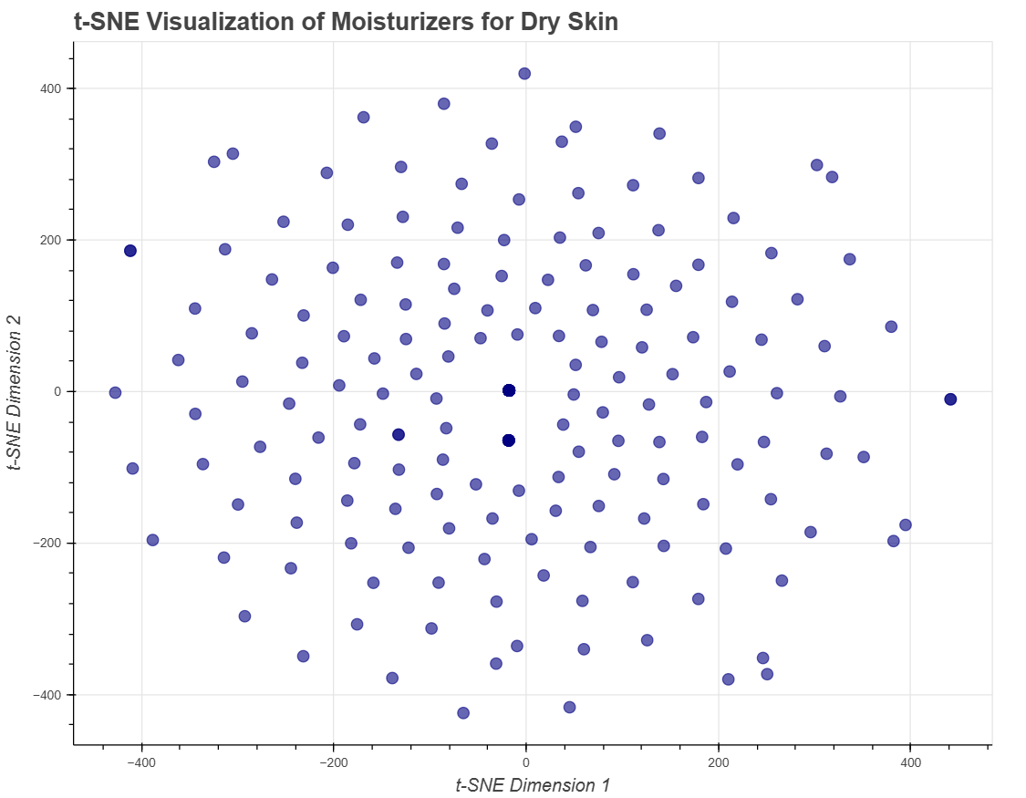
__________________________________________________________________________________
6. Comparison of Similar Products
As a demonstration, the project compares two popular cushion-based cosmetic products:
- Color Control Cushion Compact Broad Spectrum SPF 50+
- BB Cushion Hydra Radiance SPF 50
The ingredient lists of these products show significant overlap, validating the visual similarity observed in the t-SNE plot.
7. Tools and Technologies Used
- Python – Core programming language
- Pandas – Data manipulation and analysis
- NumPy – Numerical computations
- Scikit-learn – Machine learning and t-SNE implementation
- Bokeh – Interactive visualization
- Jupyter Notebook – Development environment
__________________________________________________________________________________
8. Advantages of the Proposed System
- Eliminates trial-and-error product selection.
- Helps users with sensitive or dry skin make informed choices.
- Scalable to other product categories and skin types.
- Does not require user ratings, making it effective for new products.
__________________________________________________________________________________
9. Limitations
- Binary encoding does not account for ingredient concentration.
- t-SNE is computationally expensive for very large datasets.
- The system does not consider user preferences or feedback.
__________________________________________________________________________________
10. Future Scope
- Use TF-IDF instead of binary encoding for better ingredient weighting.
- Apply cosine similarity to generate top-N recommendations.
- Integrate user profiles and preferences.
- Deploy as a web application using Streamlit or Flask.
- Extend analysis to other cosmetic categories.
__________________________________________________________________________________
11. Conclusion
This project successfully demonstrates how data science can be applied to solve real-world consumer problems. By analyzing cosmetic ingredient compositions and visualizing similarities using machine learning techniques, the system provides a transparent and effective method for product comparison. The project bridges the gap between complex chemical information and user-friendly decision-making, making it a valuable application of content-based recommendation systems.

